10/19/2022

Abdullah Shafiq

22k-4489

BSCS-1D

Programming Fundamental

Assignment 02 (Official)

**Question # 1: (10-Points)**

A smart city which is equipped with the latest technologies such as self-driving cars (SD), robots, UAV,

and many others is shown in Fig.1. Consider a UAV which is deployed to monitor the agriculture field

and communicate with the robot, which can take an N number of different locations (A, B, C, and N)

(refer Fig.1). Develop a C-script that calculates the distance between reference point R (1,3) of a UAV and robot

locations A, B, C, and N number of locations. N is the (non- zero) LSD of your mobile number.

For 0 &lt; LSD &lt; 4 then take [N = (2 LSD ) *2], and if LSD = 0, take [ N = (2 LSD ) *4+3]

Note: (Use For loop and While Loop to accomplish this task).

***Program & Output***

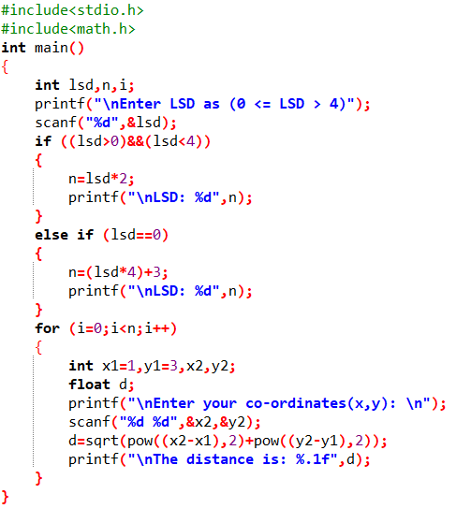***For loop:***

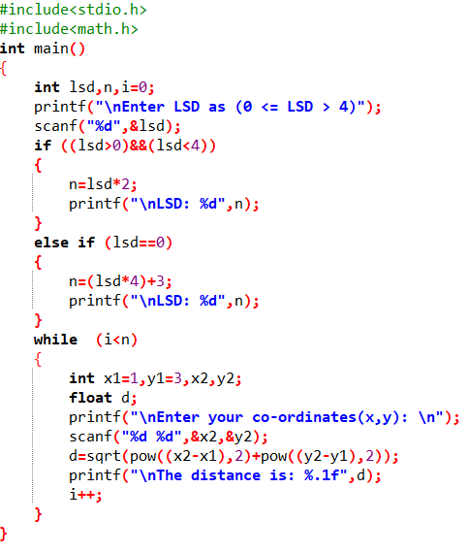***While loop:***

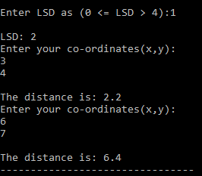

**Question # 2: (10-Points)**

Covid’19 vaccination has become a mandatory requirement for many things such as traveling, bank

account opening, admissions in higher educational universities, and many more. Develop a C- script that

facilitates the hospital in determining which person needs to be vaccinated based on age and underlying

disease. The program should run for N persons and perform the followings: (N should be taken as a user input)

I. if age is greater than or equal to 18 and person belongs to the Urban area of a city then program

should display the following message: Eligible for the vaccine. Kindly proceed for the vaccination

II. if age is less than 18 and person to the Rural area of a city then program should display the

following message Not Eligible for the vaccine. Kindly wait for the vaccination

III. Also list the possibilities in how many ways we can solve the problem given in Question no 02.

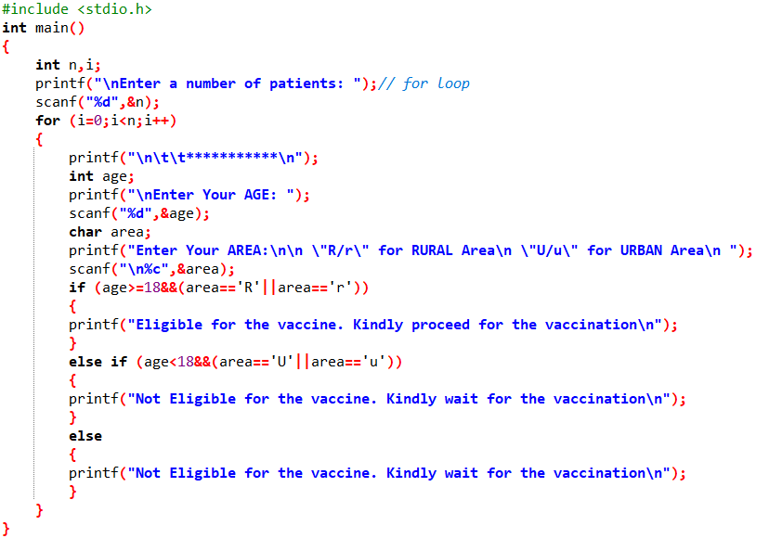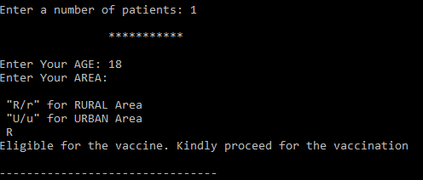***Program & Output***

**Question # 3: (10-Points)**

Alice and Bob want to exchange the n- digits message on the internet, but they want to ensure the

security. They went to a cyber security specialist Edwin for the solution. Edwin listened to the

requirement of the clients and proposed a scheme for cryptography, which is mentioned in following points

1. The algorithm would reverse the message

2. After reverting the message, it would determine an alphabetic character against the digit. For

example, for 0 it would be A, for 1 it would be B, for 2 it would be C, for Z it would be 25.

Write a code in C for the above cryptographic algorithm using loops in C for Edwin.

3. Also provide the solution for decryption the message. (System should ask user for encryption and

decryption at the start of the program)

***Program & Output***

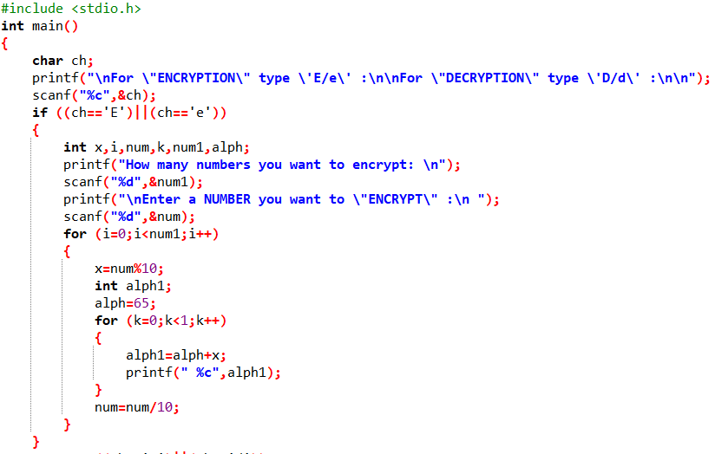

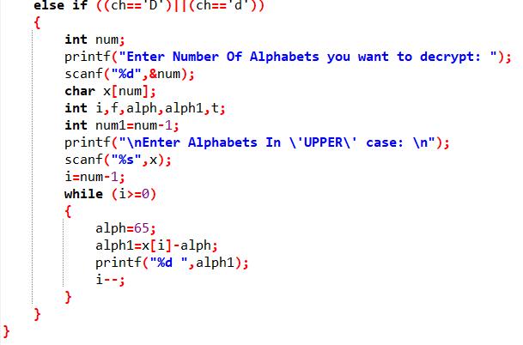

***Encryption output***

(1)

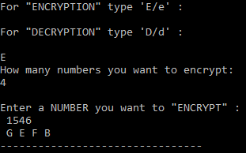

(2)

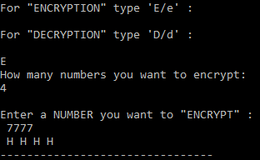

(3)

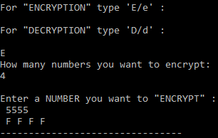

(4)

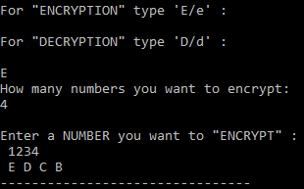

\

***Decryption output***

(1)

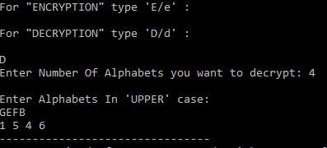

(2)

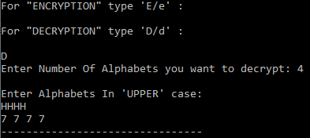

(3)

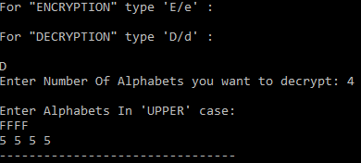

(4)

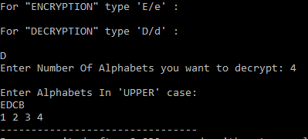

**Question # 4: (10-Points)**

A robotics and technological center offer various training and workshop sessions to the registered members. The robotics center has implemented chatbot at the main entrance for checking the membership status of the people. The chatbot is incorporated with the AI- enabling logics to check the membership status. The chatbot system displays 4-digit message randomly on the screen and after reading the message user would type the output. The main process would be: User would read the message from screen and would add (1 if he is male and, 0 if she is female) Furthermore, he/she would add age to the input. After this the user would add all the digits of the input and finally take remainder with 5 of the output.

***Program & Output***

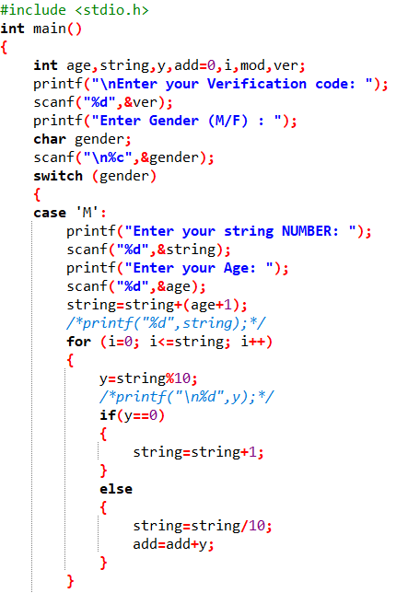

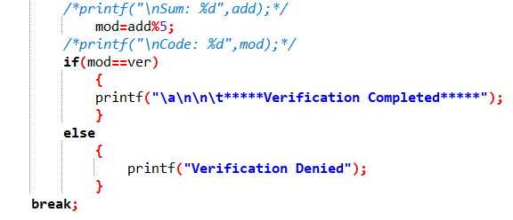

*Continue Program…..*

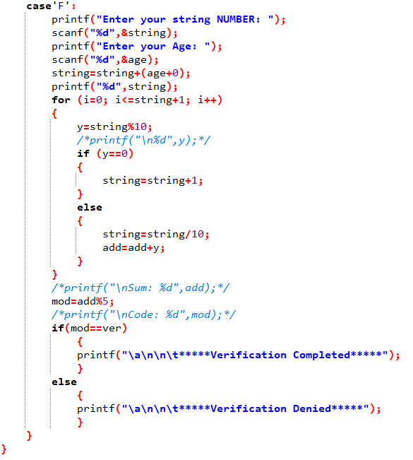

***Output for male:***

**Verification code:** 4

**Age:** 40

**String:** 3231+40+1=3272

**Code:** 3+2+7+2=14%5=4

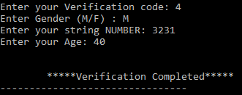

***Output for female:***

**Verification code:** 2

**Age:** 15

**String:** 1000+15+0=1015

**Code:** 1+0+1+5=7%5=2

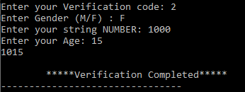

**Question # 5: (10-Points)**

Write a program for an ice-cream manufacturing company. Assuming that 50 ice-creams can be prepared each ……ice- creams that have been ordered and also whether the person required the plant to run 16hrs or 8 hrs. per day and then displays the bill for the customer that indicate the number of days and hours it will take to produce them and also the total cost of ice-creams along with their cost distribution based on plant- running time.

***Program & Output***

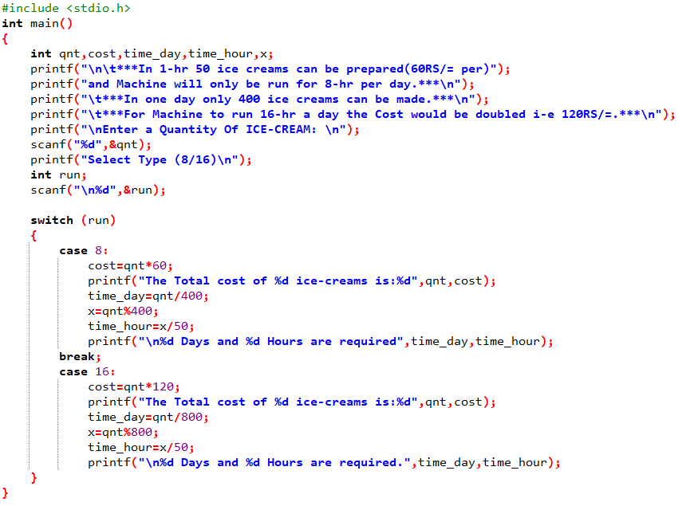



***When Machine operates for 8 HOURS:***

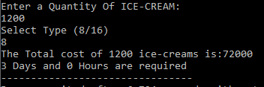

***When Machine operates for 16 HOURS:***

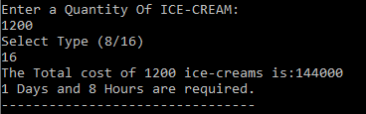

**Question # 6: (10-Points)**

An unarmed vehicle (UAV) is operating in a smart environment where it is communicating with a mobile device and a self-driving car (refer Fig.2 Drone Alpha). The UAV is equipped with an AI facility, and it displays the pattern A when it communicates with the SD. On the other hand, it shows pattern B when it starts communication with the mobile device. Develop a C-script that is needed to be integrated into UAV, which generates pattern A (refer fig.2) for SD car and pattern B (refer fig.2) for mobile device

***Program & Output***

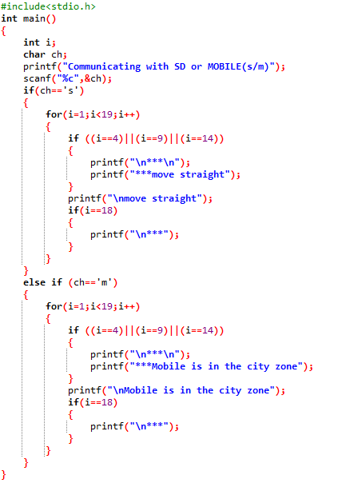

***Communicating with SD:***

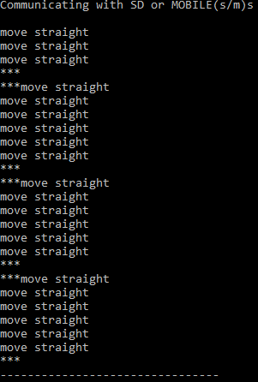

***Communicating with MOBILE:***

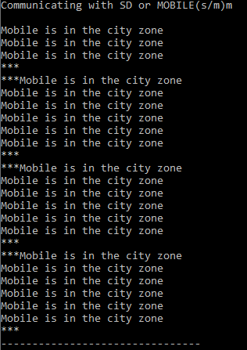

***The End.***